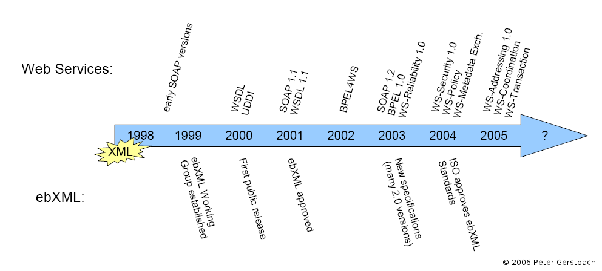
Timeline

What is a Timeline?
A timeline is an actual picture of events that happened in history. Timelines can be LINEAR or COMPARATIVE. You will be doing a linear timeline.
A linear timeline shows a picture of events as they occurred in a certain period of time. Use a linear timeline for one subject and time frame. A linear timeline can be written horizontally or vertically, for example:
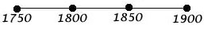
Getting Started
- The timeline should start with statehood and continue through today.
- You must include 10 events that occurred in your state.
Writing Your Timeline
After you have gathered your facts, you are now ready to lay them out in chronological order to create a timeline. At the beginning of your timeline, mark the starting date and what happened on that date. Next, go to the end of the timeline and mark the ending date and what happened. In between these dates, mark the other important dates and what happened.
Wrapping It Up
- You can't include everything that happened - choose what's most important or interesting to you.
- Don't forget to list an event for every date on the timeline.
- You are the HISTORIAN - what you put on your timeline will affect how others view your state.
- Step back from your timeline and ask yourself some questions about the timeline. For example: What does the sequence of events suggest about history? How did earlier events affect later ones?

