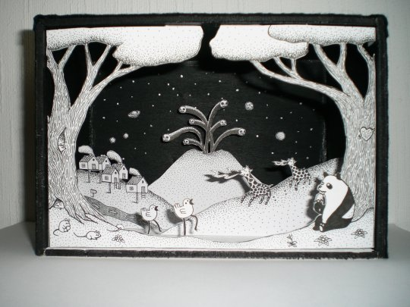
Diorama

With this activity you will be creating a 3-D representation of a place of interest in your state. You will need to do the following to be considered complete:

You will need:

• A shoe box or similar sized box (keep lid if you have one.)
• Paper
• Pencils, crayons, markers
• Glue
• Yarn, scraps of material or anything for extra effects.

Step 1: Pick the place
• Decide on a place of interest (for example: rainforest, resort, national park, tourist location)

Step 2: Set the scene
• Cut a piece a paper to fit the back (inside) of the box and two pieces for the sides.
• Draw the setting on these pieces of paper. (For example; the rainforest theme would have trees and vines) Color.
• Paste the setting pieces in the box.

Step 3: Add the pieces
• Draw and color individual pieces: (for example; the rainforest would have monkeys, snakes, butterflies, parrots, etc.).
• Decide where you want these to be in the diorama.
• Some should be in the rear and some in the front, some can hang from the top or be attached to the side. Use yarn to hang things. HINT: To make your objects stand up, fold the bottom 1/4 inch back. Glue the bottom to the floor of the diorama. If the object falls backward, make a small strip and attach it to the back of the object on one side and the other side can be attached to the back or bottom.
Step 4: Add the extras
• Use the extra materials to add the finishing touches. You can use small plastic animals, people, etc. Have fun.

Step 5: Explain
Write a paragraph explaining what your diorama represents and why it is important to your state.

